**Case Study – Bookshop Dataset**

This case study aims to study data modelling and data preparation for analysis. You have to understand the data model given in the diagram and create accordingly in Tableau after reading data from the datasets.

After creating the data models, you have to add appropriate screenshots with explanations on submit your work as a pdf/word file. The document must explain your preliminary notes on the dataset. You can add as many points as you want beyond the given hints.

About the data set

Bookshop consists of 13 tables, combined in the following manner:

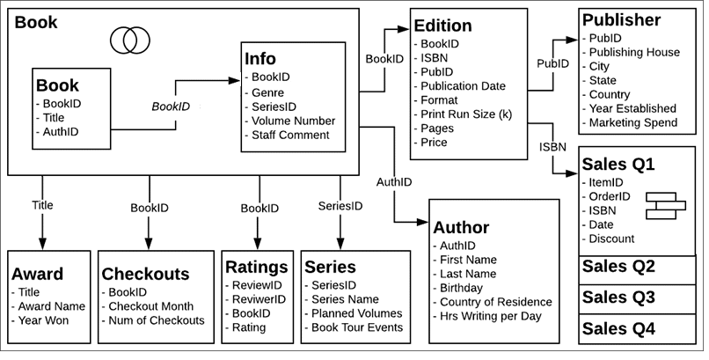

Based on the provided description, build a data model on the dataset. Perform preliminary data analysis using following pointers.

Q. Count the number of books in the inventory.

Q. Count the number of authors.

Q. How many books have received 5-star rating?

Q. To which all countries the Authors belong to?

Q. Name the top 5 books by sales.